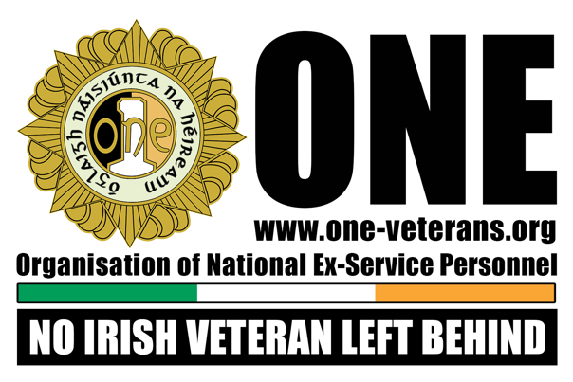

Veteran Support Officer- Job Description
Position Title | Veteran Support Officer, Cork & Kerry Region
Programme: | Óglaigh Náisiúnta na hÉireann (ONE) Veteran Support Officer
The Employer | ONE’s primary objective is to support the needs of veterans by the provision of accommodation in its Veterans’ Homes and advice and support, both professional and peer-to-peer, through our nationwide network of Branches, Veteran Support Centres and Veteran Support Officers.  ONE is a registered charity.  Peer support is part of a range of veteran support services available for all who served in the Defence Forces at any level.  ONE recognises that to maintain and develop top class Veteran Support Centres, we need to be proactive in empowering veterans.
Work Schedule | Full Time 38.5 Hours per week
Contracts & Location | 1 Year Contract (renewable subject to funding) Óglaigh Náisiúnta na hÉireann, Veteran Support Centre, Campfield, Collins Bks, Cork
Salary Incremental Scale (TBC prior to interviews) | €40,039, €41,468, €42,912, €44,358, €45,829, €47,534
Role Purpose: | To provide a critical service in our Veteran Homes and Veteran Support Centres to veterans experiencing difficulties. Many come to ONE with depression, disabilities, PTSD, or having suffered family breakdowns, with little support to call on.  Our services are challenging environments as we seek to achieve an inclusive approach working with veterans who may have complex issues.  This role is completely client focused consistently seeking the best outcome for those we work for.
Reports to: | Chief Executive Officer, Óglaigh Náisiúnta na hÉireann
The Role: | Key Responsibilities:  - To implement the case management system and engage in one-to-one work with a specific allocated case load, from referral stage to disengagement. This includes assessment, developing and implementing a comprehensive support plan, updating the ONE system, advocating on behalf of the veteran, arranging meetings, linking the veteran in to appropriate services, assisting each veteran in finding a long-term home.  - To engage with and build professional trusting relationships with individual veterans and families, treating them with dignity and respect, and working within the values of Óglaigh Náisiúnta na hÉireann  - To carry out all duties connected with the operation of a residential service, resolving conflict, responding to health issues, taking referrals, welcoming, and engaging with residents  - To liaise with and advocate to a broad range of external service providers in addition to internal services  - To work effectively as part of a team and being open to reasonable requests from Chief Executive Officer, Óglaigh Náisiúnta na hÉireann to ensure effective working relationships and responses to residents  - To work within the policies and procedures of Óglaigh Náisiúnta na hÉireann and the standard operating procedures of the organisation
Essential Requirements | Qualification Required  - Professional Qualification in Counselling/Psychotherapy of at least 3 years Diploma Standard recognised by a relevant professional body such as IACP.  OR  - Professional Qualification in Counselling Psychology from Accredited Training School recognised by a relevant professional body within the Irish Council of Psychotherapy (ICP) or PSI.  Experience Required  - A minimum of 2 years post qualification experience of managing a case load under supervision.
Desirable | - Work experience and employment in a military environment, homeless services, addiction services residential services, community and/or the youth work sector.
 | - Additional training in:  Mental Health  Suicide Studies  First Aid, CPR, AED | ASIST  Case Management  STORM  CISM  Stress Management
Application Process | Applicants should send their CV (2 pages max) & Cover letter showing how they meet the selection criteria & e-mail it to cormac@oneconnect.ie or send it to Human Resources Dept., Óglaigh Náisiúnta Na hÉireann, Brú na bhFiann, Smithfield Market, North King Street, Dublin 7, Ireland  Closing date for applications will be the 08 April 2024 and interviews will be held the week commencing 15 April 2024.  ONE is an equal opportunities employer  Garda Vetting will apply to this role

